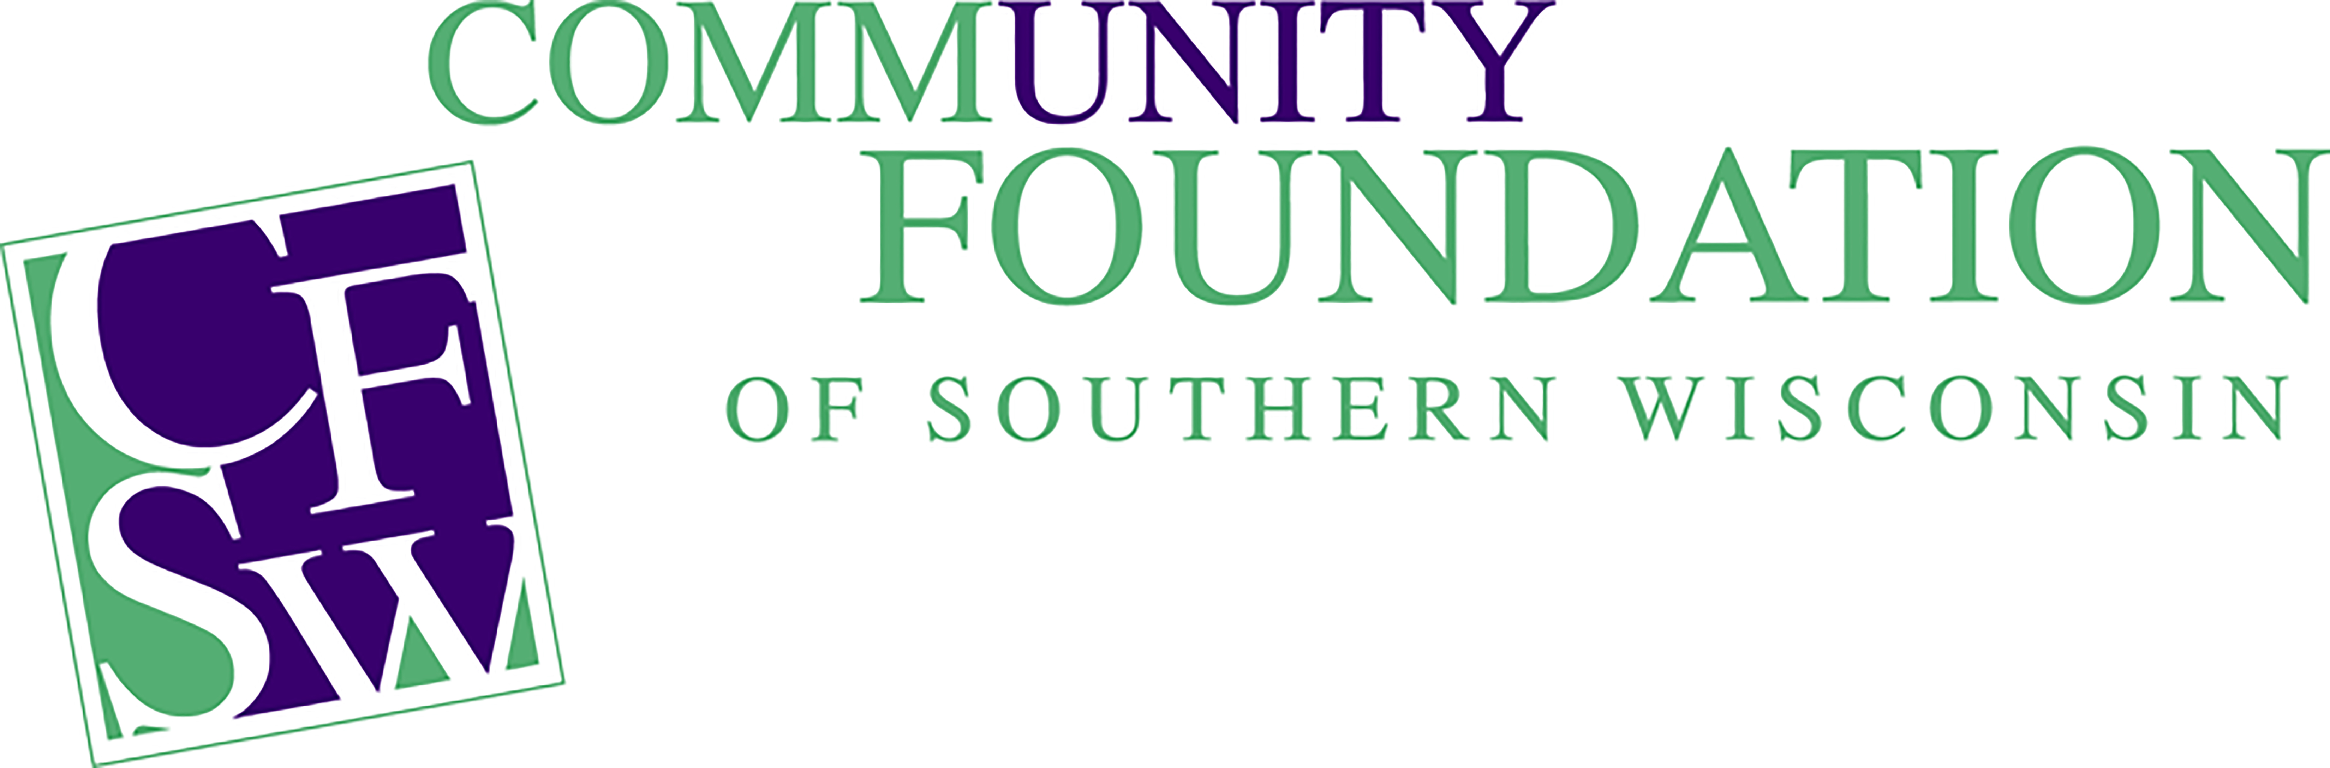
EMPLOYMENT OPPORTUNITY

Donor Services Representative

Description of Position: Donor Service Representative works directly with Community Fund Boards, organizations and individual donors to attract and manage charitable gifts and bequests maintaining and enhancing their philanthropic goals. This position will serve Rock and Walworth Counties in the cultivation and stewardship of relationships with donors to secure necessary funds; provide analysis and financial reporting of major and mid-level donors; and provide direct management and advice to regionally assigned Community Fund Boards.

Reports to: Director of Donor Services

Supervisory Responsibilities: None

Expected Hours of Work: 30 – 37.5 hours per week between 8:30 am to 4:30 pm. Some nights and weekends may be required to accommodate donor visits and committee work.

Travel Requirements: Yes, regionally as needed throughout Southern Wisconsin. Most travel will be within Rock and Walworth counties.

Major tasks and scope of responsibilities:

Fund/Donor Development
- Identify, educate and cultivate prospective donors
- Maintain positive relationships with donors and professional advisors
- Complete all paperwork related to CFSW Funds
- Stay current with CFSW policies and procedures

Staff Support
- Assist Community Funds with meeting preparation, disbursement of agendas, minutes, financials, etc.
- Assist Community Funds with Grant requests and Annual Grant Cycles
- Attend board and committee meetings as needed
- Assist Community Funds with annual event planning and coordination
- Share CFSW Mission and assist community fund boards in development of their vision and purpose
- Assist community fund boards with publicity, presentations, direct mailings, grantmaking process, etc.
Foundation Operations
- Assist in gift receipts and review process
- Help coordinate donor touches for the CFSW region
- Maintain CFSW donor database
- Analyze and streamline CFSW processes
- Assist in the review of CFSW policies
- Coordinate CFSW fund audit and updates

Community Catalyst
- Maintain an awareness of community needs and serve as a community resource
- Identify challenges and opportunities facing the communities
- Communicate CFSW grant cycles and ensure an ongoing process of prudent and creative grants to address current and emerging community needs
- Establish and maintain contacts with community nonprofit organizations
- Be knowledgeable and able to facilitate endowment planning, development, and growth planning for organizations
- Understand, support and communicate the Mission of CFSW

The noise level in the work environment is usually moderate.

The above statements are intended to describe the general nature and level of work performed by the incumbent in this position. They are not intended to be an exhaustive list of all responsibilities, duties and skills.

APPLICATION PROCEDURE

Submit a cover letter explaining your interest in the position and describe your strengths relative to the positon description. Please also share what you would contribute to the Community Foundation of Southern Wisconsin. Please provide a resume and cover letter.

Application deadline: open until filled.

Due to the nature of this position, a valid driver’s license and reliable transportation are required; may use public transportation when and if available and practical.

Qualifications:
- Bachelor’s degree and/or three or more years’ experience in customer service, community service and/or nonprofit work preferred
- Must be a self-directed team player with good oral and written communication skills
- Must enjoy working with a wide variety of personalities
- Must be able to serve as an advocate and an educator for personal philanthropy
- Must have a valid driver’s license
- Must be willing and able to work a flexible schedule in order to meet the needs of the Community Funds as well as donors and their professional advisors
- Must perform responsibilities in a professional manner and handle assignments with a high degree of accuracy and confidentiality
- Must be able to lift up to ten (10) pounds

Preferred Qualifications
- Experience within a community foundation/nonprofit environment, and particularly with Foundant’s Community Suites is a plus.

To Apply:
Interested candidates should e-mail their resume with cover letter to: wyatt@cfsw.org
If you have any questions, please contact Wyatt Jackson, President/CEO at (608) 758-0883
Location: Janesville, WI

The Foundation is an equal opportunity employer and welcomes a diverse pool of applicants.

